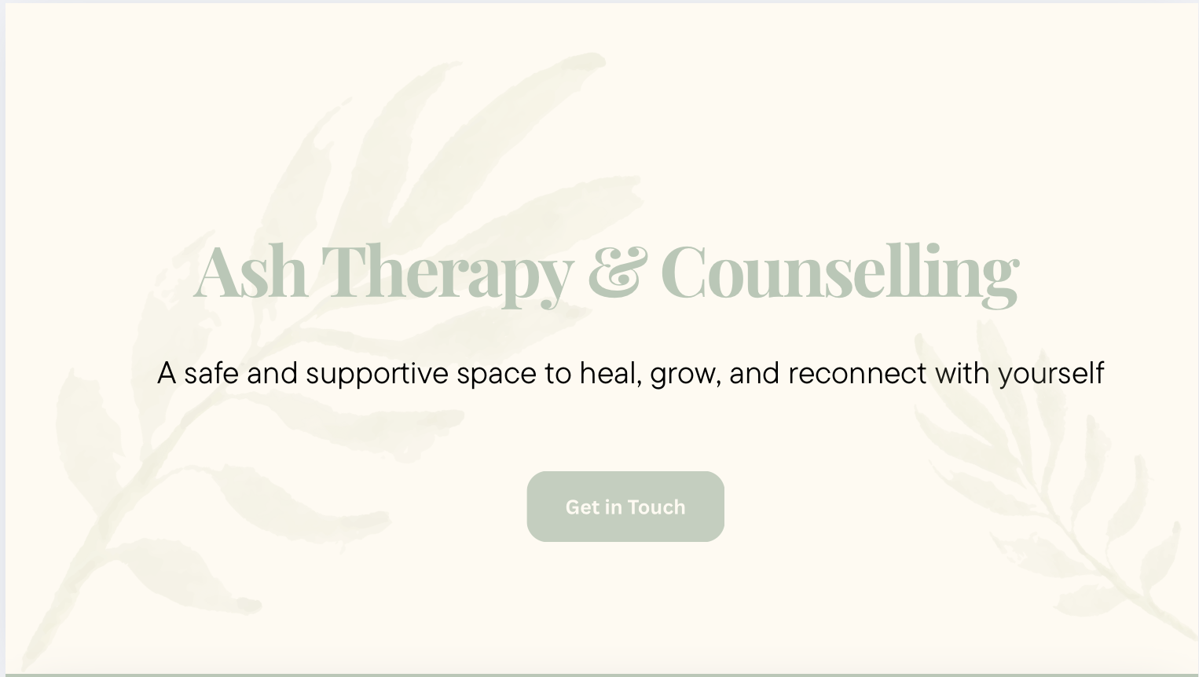

Sample colour palette and opening page

About Me
As an integrative counsellor and psychotherapist, I know how important it can feel to have someone who genuinely listens. Life has its challenges, and there were times in my own journey when I longed for someone who could really hear me. That experience shapes the gentle, grounded way I hold space for others now.
I offer a caring and non judgemental space where you can talk openly and explore what has been weighing on you. I use a blend of person centred, attachment and CBT approaches, but mostly I am here to listen, to understand and to support you as you make sense of things, heal and feel more grounded in your everyday life. My approach is warm, gentle and trauma informed.
I am a registered member of the BACP and hold an MSc in Integrative Counselling and Psychotherapy, as well as a BSc (Hons) in Psychology.

Areas I Work With
I offer therapy for adults and young people aged 16 and over, supporting a wide range of difficulties, including:
- Anxiety
- Depression and low mood
- Low self esteem and confidence
- Shame and guilt
- Stress and burnout
- Trauma (past or recent)
- Grief and loss
- Relationship difficulties
- Identity exploration
- Addiction and recovery
- Life transitions and personal growth
- Feeling stuck or needing someone to talk to

How We Work Together
In our sessions, we will explore what has been feeling difficult for you at a pace that feels manageable and safe. You are welcome to bring whatever is on your mind, whether it is something specific or a general sense that things feel heavy, confusing or stuck. There is no right or wrong way to begin.
We might look at what is happening in your life right now, and if it feels helpful, we can gently explore what has shaped you. This is not about finding fault or giving you a label, but about understanding your experiences and how they may be affecting you today. If it feels useful, I can offer tools and strategies from CBT, but our work will always stay grounded in what feels right for you.
My role is to offer a calm, accepting and steady space where you can talk openly and feel heard. A space where you can slow down, reflect and begin to navigate your experiences with more clarity, self compassion and grounding.

Free 20 Minute Consultation
I offer a free 20 minute consultation where you can share a little about what has brought you here and ask any questions you might have about therapy. This time is simply a gentle first step so you can get a sense of how it feels to talk with me and whether I might be the right person to support you.
There is no pressure or expectation to commit. You are welcome to use the space in whatever way feels most comfortable, whether that is speaking about what is on your mind, exploring what you are looking for, or simply getting a feel for what working together might be like.

Fees and Availability
I currently offer online therapy through Microsoft Teams. Each session lasts 50 minutes and is priced at £50.
Sessions usually take place weekly, but we can discuss what feels right for you. There is no long term commitment and you are welcome to go at a pace that feels comfortable.

Contact
If you would like to get in touch or have any questions, you are welcome to reach out. You do not need to know exactly what you want from therapy before contacting me. Sometimes the first step is simply starting a conversation.
You can email me at ashsach25@outlook.com or fill out the contact form on this website. I will get back to you as soon as I can. There is no pressure or expectation. This is just a gentle first step toward support.

Cancellation Policy
If you need to cancel or rearrange a session, I kindly ask for at least 24 hours notice. This allows me to offer the time to someone else who may be waiting for support. Sessions cancelled with less than 24 hours notice may be charged.

Online Therapy
All sessions take place online through Microsoft Teams. You will receive a secure link before each session, and you can join from anywhere you feel comfortable and private. Many clients find online therapy more accessible and flexible, and it can offer a sense of comfort being in your own environment.
You will need a quiet space, a stable internet connection and a device with a camera and microphone. If you are unsure about working online, we can talk about this in your consultation.

Frequently Asked Questions
Do I need to prepare anything for therapy?
No preparation is needed. You can come as you are and talk about whatever feels important or present for you.
How often will we meet?
Most clients choose to meet weekly, but we can discuss what feels right for you.
How many sessions will I need?
There is no set number. Some people find a few sessions helpful, while others prefer longer term therapy. We will review together as we go.
What if I feel nervous about starting therapy?
It is very natural to feel unsure or anxious. We will take things at your pace, and you do not need to share anything before you feel ready.
Is everything confidential?
Yes. Everything you share in therapy is confidential, except in very rare circumstances where there is a risk of serious harm. We will talk about this clearly in your first session so you know exactly what to expect.

